C PROGRAMMING TO GENERATE FIBBONACCI SERIES WITHOUT USING RECURSION

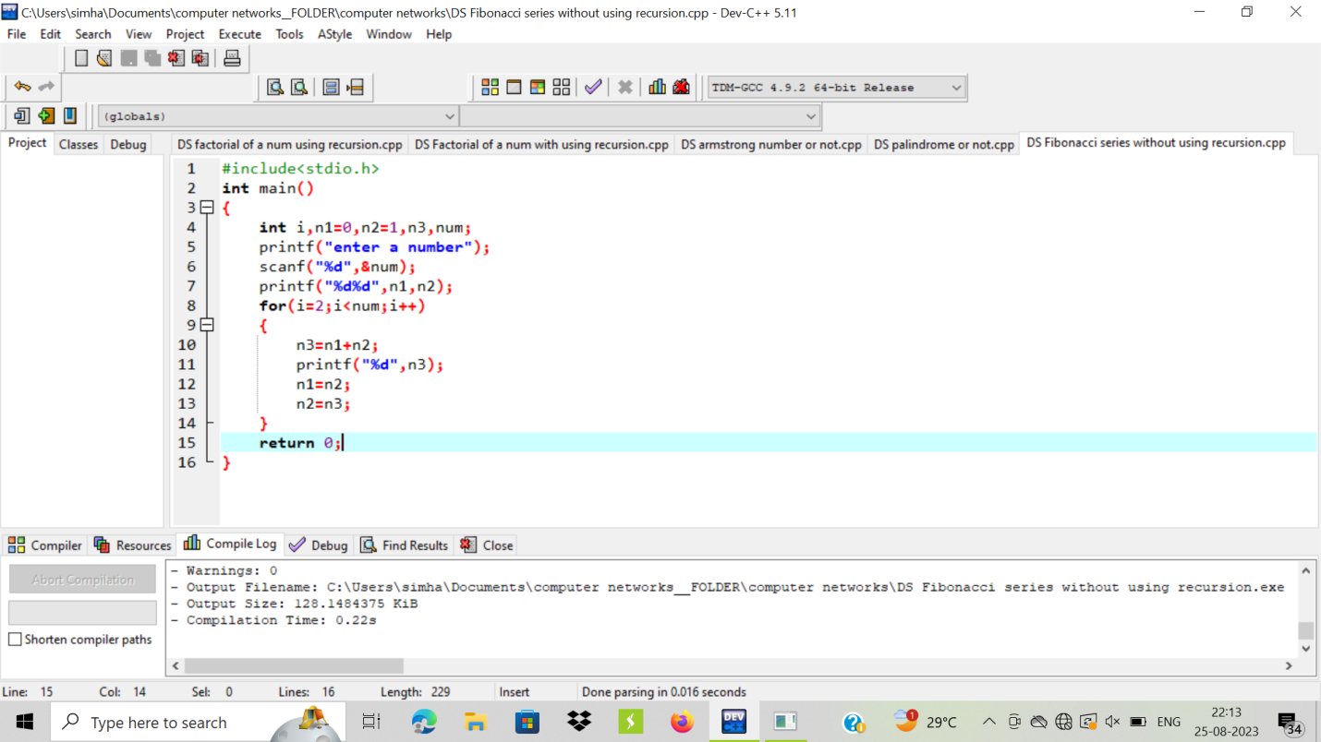

OUTPUT:

